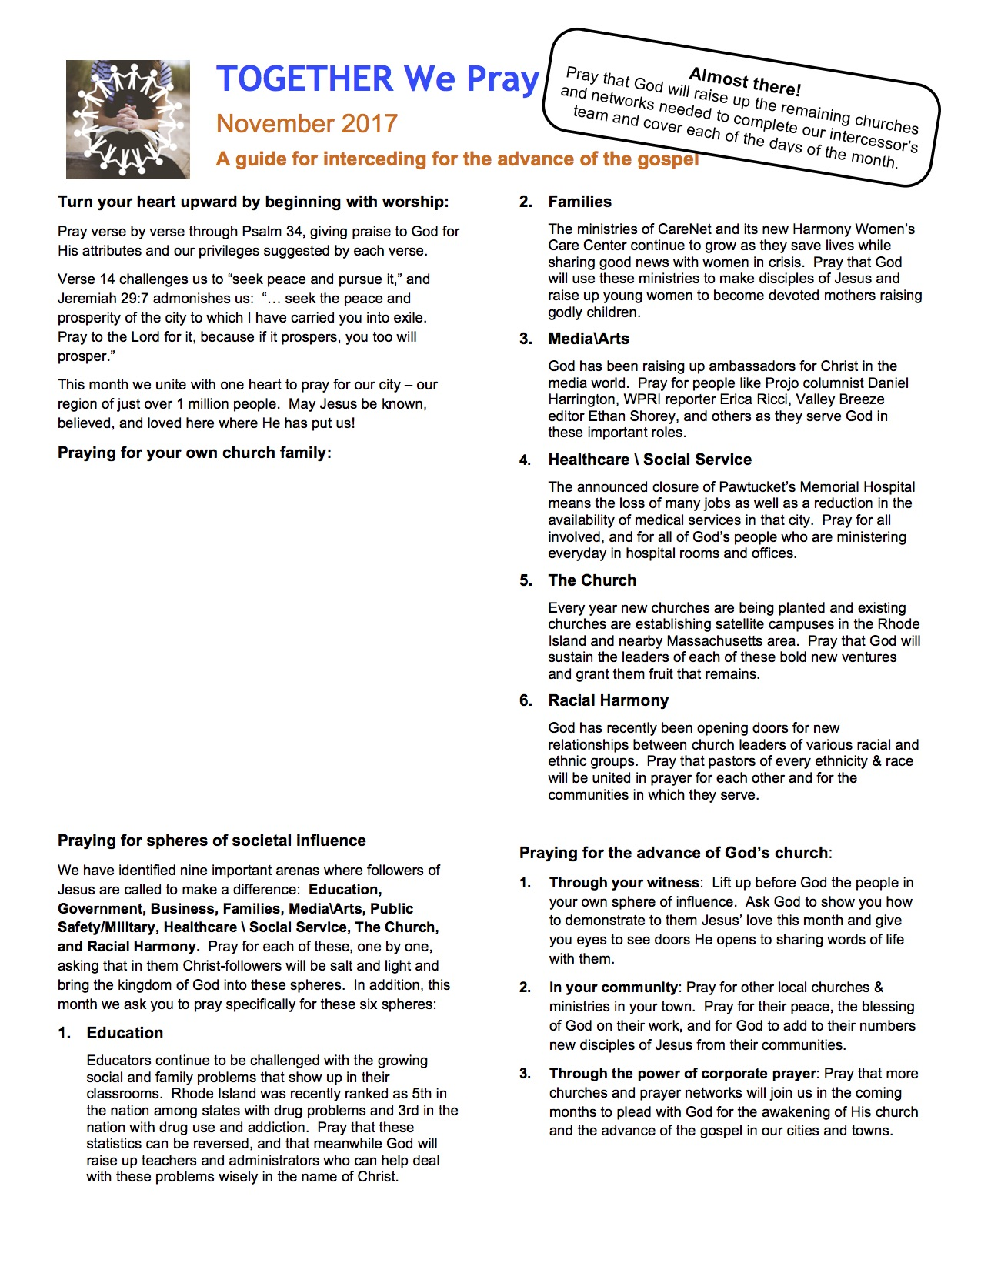

(PASTOR OR PRAYER COORDINATOR: Provide specific prayer suggestions for your own church and its ministry here. Try to focus on the bigger picture of your individual and corporate impact on your community.)